Lab No. 10
Import Necessary Libraries:
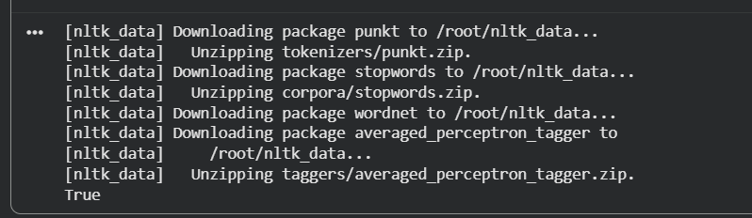

Part I
- Input Text & Word Tokenization:

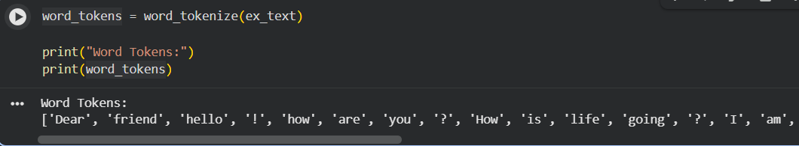
- Sentence Tokenization:

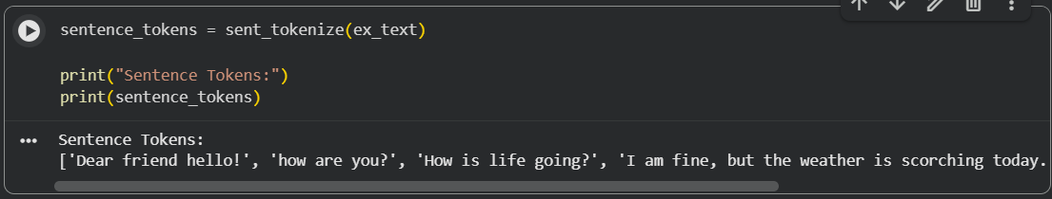
- Remove Stop words:

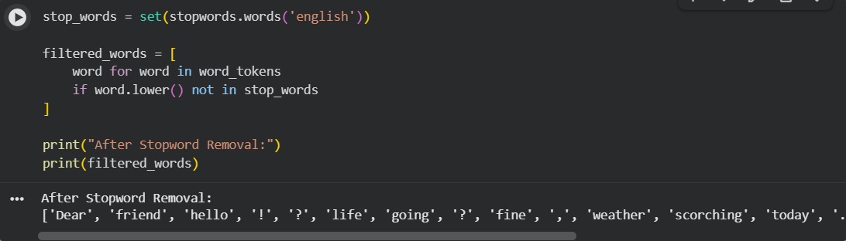
- Remove Punctuation Using Regular Expression:

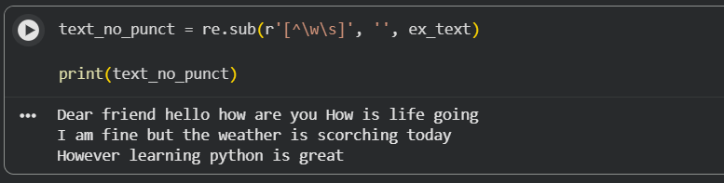
- Remove Punctuation Using NLTK:

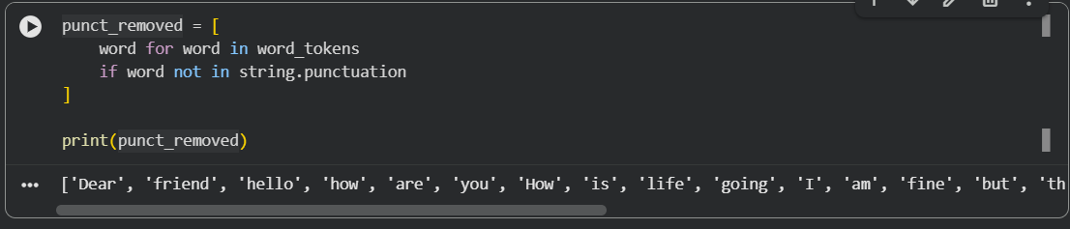
- Stemming 1:

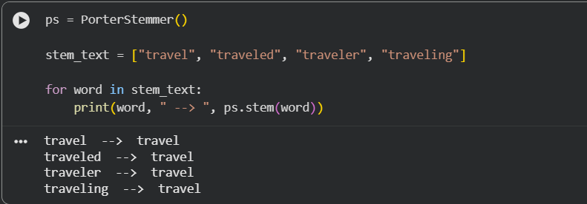
- Stemming 2:

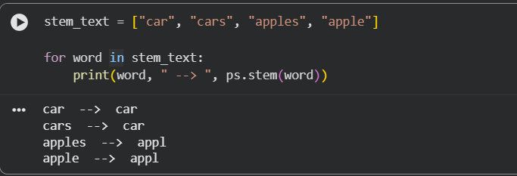
- Stemming 3:

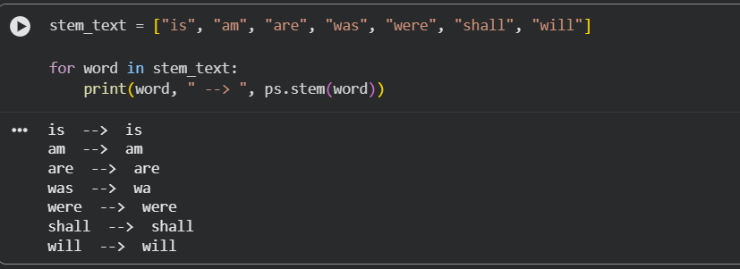

Lab Task I
- Read Text File and Convert to DataFrame:

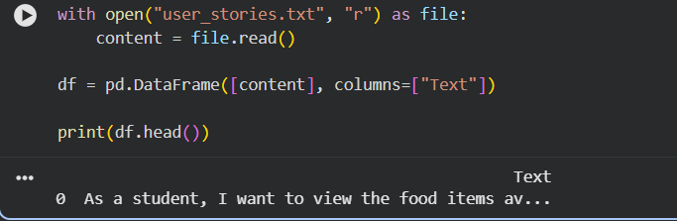
- Apply Tokenization, Stopword Removal, and Stemming:

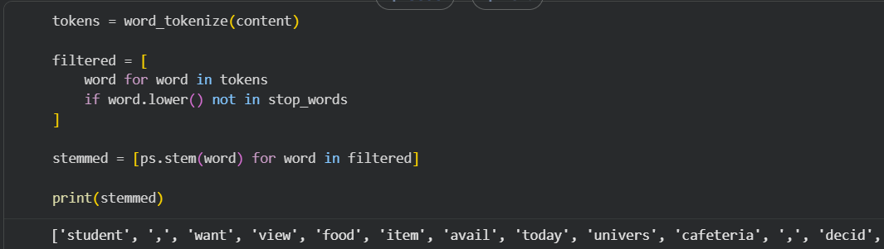
- Display All English Stopwords:

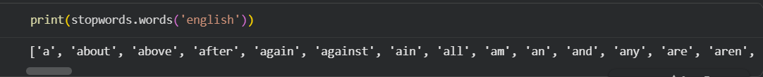

Part II
- Given Data & Create DataFrame:

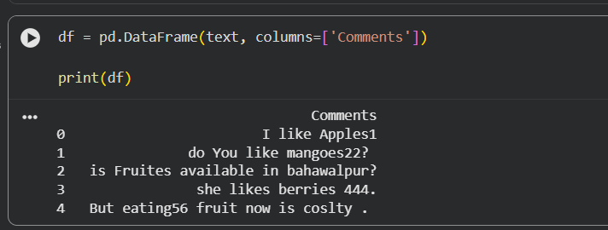
- Removes White Spaces:

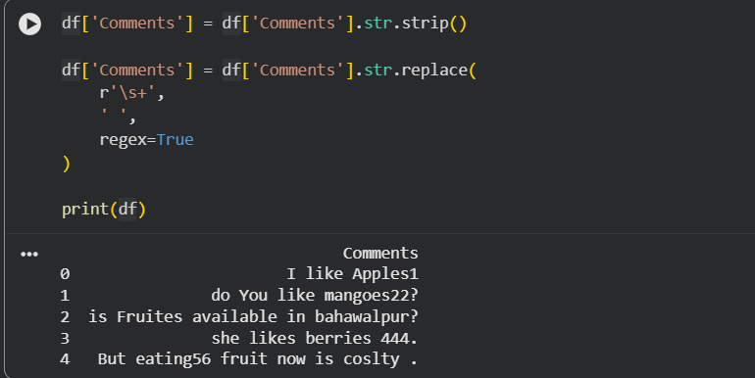
- Remove Digits:

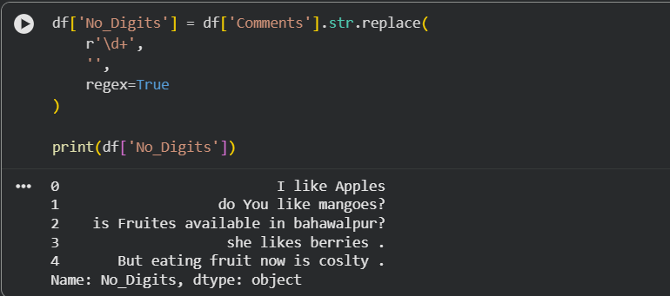
- Lower Case Normalization:

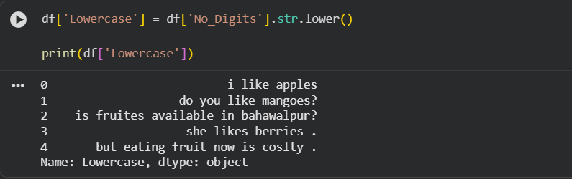
- Upper Case Normalization:

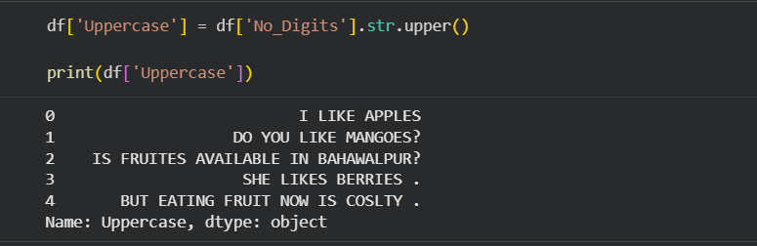
- Lemmatization:
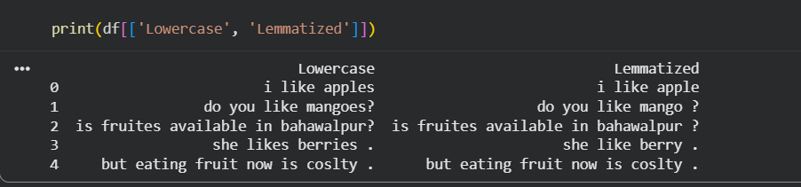

Lab Task II
- POS Tagging:
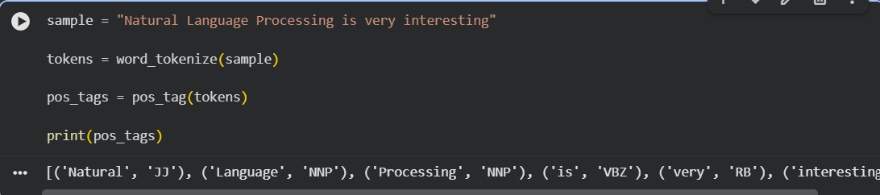
- Remove Words Less Than 3 Characters:
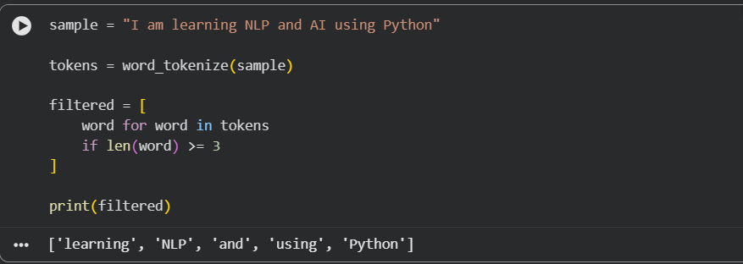
- Spelling Check (TextBlob):
